**DAILY ONLINE ACTIVITIES SUMMARY**

|  |  |  |  |  |  |  |  |  |
| --- | --- | --- | --- | --- | --- | --- | --- | --- |
| **Date:** | **03-06-2020** | | | | | **Name:** | **Preethi** | |
| **Sem & Sec** | **6th - B** | | | | | **USN:** | **4AL17CS065** | |
| **Online Test Summary** | | | | | | | | |
| **Subject** | | **PAP assignment 1** | | | | | | |
| **Max. Marks** | | **20** | | **Score** | | | **18** | |
| **Certification Course Summary** | | | | | | | | |
| **Course** | **Introduction to Cloud Computing** | | | | | | | |
| **Certificate Provider** | | | **Cognitive Class-IBM**  **DeveloperSkillsNetwork** | | **Duration** | | | **10 hours** |
| **Coding Challenges** | | | | | | | | |
| **Problem Statement:2 Python and 1 java program** | | | | | | | | |
| **Status: executed** | | | | | | | | |
| **Uploaded the report in GitHub** | | | | | **Yes** | | | |
| **If yes Repository name** | | | | | <https://github.com/PreethiNayak/Daily-Status/tree/master/03June2020> | | | |
| **Uploaded the report in slack** | | | | | **Yes** | | | |

Online Test Details: (Attach the snapshot and briefly write the report for the same)

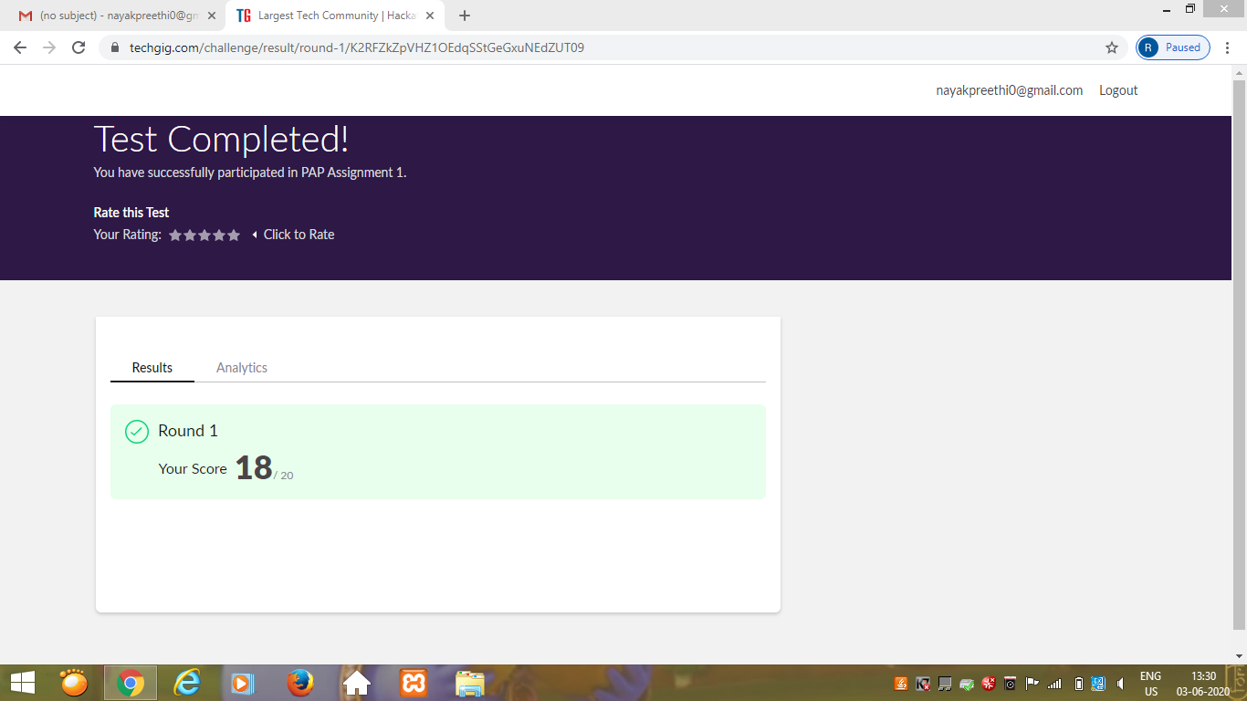

Certification Course Details: (Attach the snapshot and briefly write the report for the same)

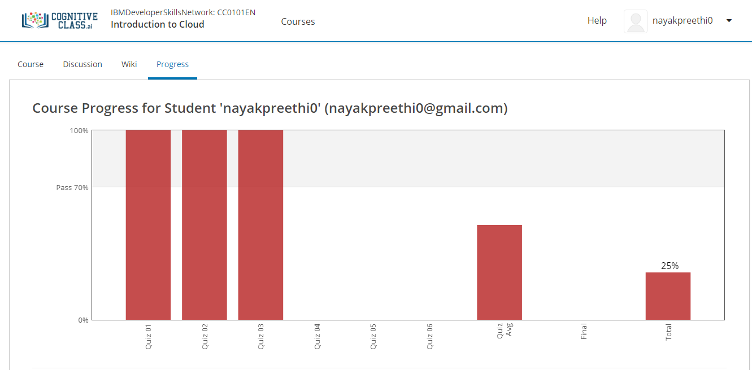

Today I completed module 3 –“Cloud computing Service and Deployment Models”

In this I learnt,

1. Introduction and Objectives of this module.

2.Overview of Service models.

3.IaaS(Infrastructure as a Sevice),PaaS(Platform as a Service),SaaS(Software as a Service).

4.Public Cloud,Private Cloud and Hybrid Cloud.

Coding Challenges Details: (Attach the snapshot and briefly write the report for the same)

Program 1

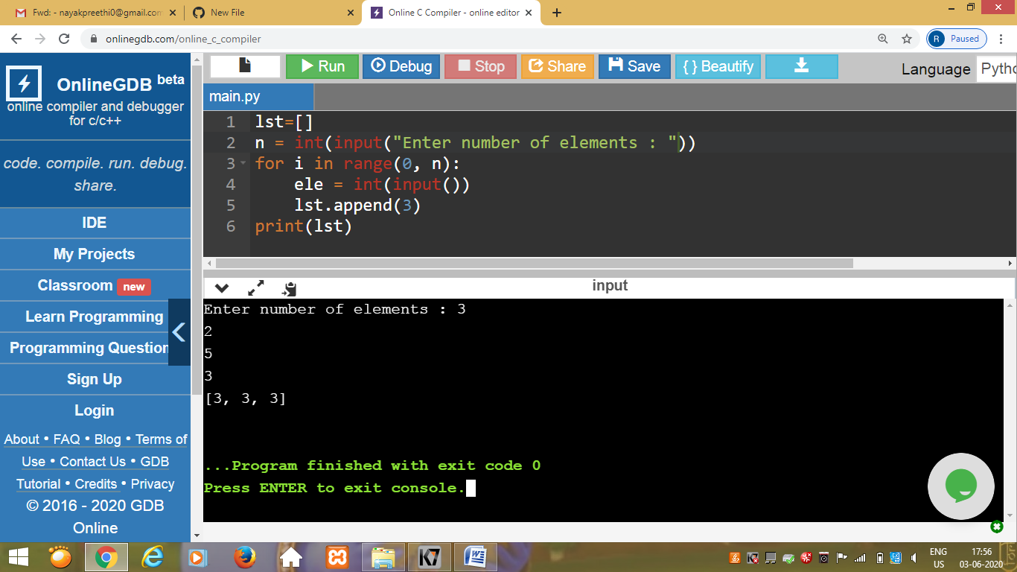

This is output of python program that take a list of length 3 containing integers, find out which is larger, first or last one and set all the elements in the list to be that value and print the updated list

Program 2

This is the output of the python program to generate prime number in an interval.

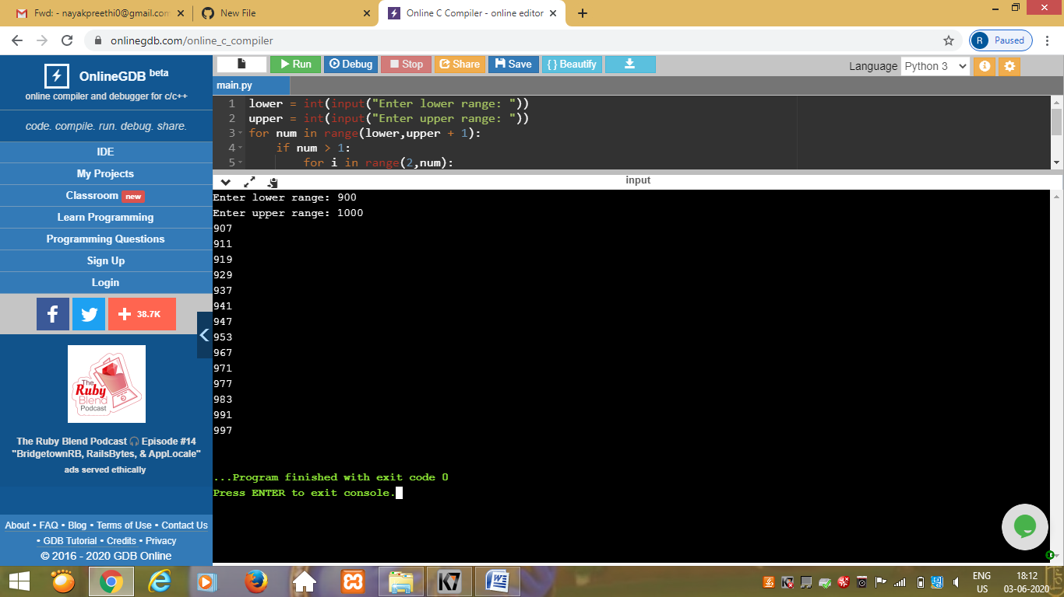

Program3

This is the output of the java program to Implement Circular Doubly Linked List.

